**u|Lg ;f];fO6L klAns :s'n**

**D- 22**

**/Tggu/–&, ;f}/fxf lrtjg**

**klxnf] q}dfl;s** परीक्षा**—@)*@**

**sIff M– Pn= s]= hL= समय - @ 3+=** **k"0f{fÍM– %)** **ljifoM– g]kfnL**

|  |
| --- |
| **gfd : ====================================================/f]n g+=============;]S;g M ================** |
| **_________________________ ______________________ s'n k|fKtf**Í **:**  **lg/LIfssf] ;xL k/LIfssf] ;xL** |

**k|Zg g+= ! jfSo k9\g'xf];\ / n]Vg'xf];\ . -#_**

**hn e/ .**

**a; r9 .**

**snd ug .**

**k|Zg g+= @ p:t} cIf/df uf]nf] 3]/ nufpg'xf];\ . -%_**

**cÖ cf c**

**cfÖ 5 cf**

**pÖ O p**

**OÖ 8 O**

**cf]Ö cf] c**

**k|Zg g+= # zJb agfpg'xf];\ . -%_**

**k|Zg g+= $ lrq x]/L klxnf] cIf/ n]Vg'xf];\ . -%_**

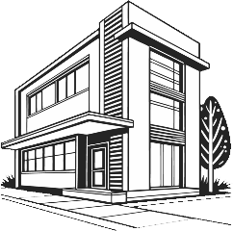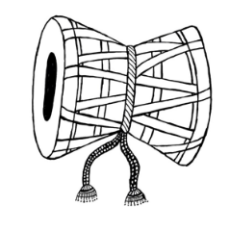



**k|Zg g+= % s|d ldnfP/ hf]8\g'xf];\ . -%_**

**r 5 ` 6**

**h em 7 8**

**9 0f**

**k|Zg g+= ^ b'O{ cIf/n] ag]sf zAbx? n]Vg'xf];\ . -%_**

**k|Zg g+= & k5fl8 cfpg] cIf/ n]Vg'xf];\ . -^_**

**u 8 r**

**h 6 k**

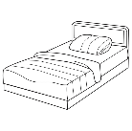**k|Zg g+= * zAb / lrq lar hf]8f ldnfpg'xf];\ . -^_**

**sk**

**hu**

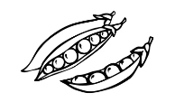**an**

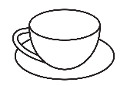**knª**

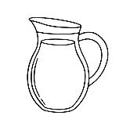**sdn**

**d6/**

**k|Zg g+= ( vfln 7fpF eg'{xf];\ . -!)_**

t b g k a d+ n z ; If 1 .

**;dfKt**